Correction of Ball Grid Array Shape on Printed Circuit Board (PCB)

1*Rohit Das,*2*Chiou-Shann Fuh* (傅楸善)

1Department of Computer Science and Information Engineering,

National Taiwan Normal University, Taipei, Taiwan,

2Department of Computer Science and Information Engineering,

National Taiwan University, Taipei, Taiwan

E-mail: [rdas.879@gmail.com](mailto:rdas.879@gmail.com) , [fuh@csie.ntu.edu.tw](mailto:fuh@csie.ntu.edu.tw)

#### Abstract

In our project, we attempt to reconstruct 3D solder balls on the PCB (Printed Circuit Board) according to 128 projections of X-ray images of those solder balls. We mainly use different image reconstruction techniques from sinogram and fix the shape of the solder balls.

**Keywords:** Solder Balls; 2D Reconstruction;

ART; MART; SART; FBP

**1. Introduction**

Manufacturers of PCB (Printed Circuit Board) need to ensure the quality of their products. Therefore, it is necessary for them to have an effective method to inspect their product in order to find out if there are any defects. For example, there may be some cracks or voids in the solder ball, which cannot be seen easily in visible light. However, if we can get the X-ray image of solder balls, we can find the cracks in it. Furthermore, 2D image contains more information and can be easy to understand. After realizing the significance of this research, we have tried different methods to reconstruct the image of solder balls. We also use laminography to reconstruct the cross-section image on the focal plane of our X-ray system. Further, in order to get a more accurate 3D model, we create an original method which can provide us with a more accurate result. This method can benefit the inspection industry especially the ones focused on finding the quality of PCB

**2. SYSTEM SETUP**

Reconstruction plays a vital role in inspection because the better result of the reconstruction, the more effective we inspect the defects. The structure in our projection system is illustrated as follows: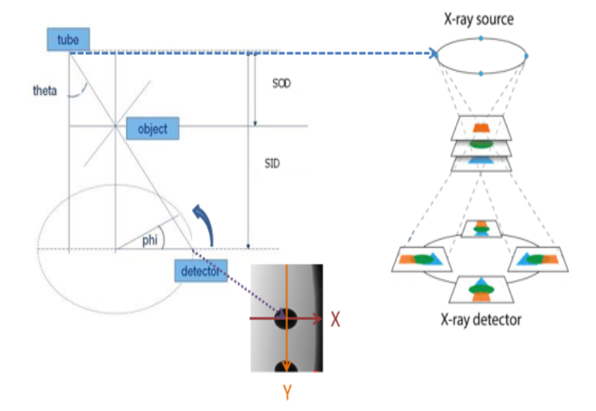Figure 1: System setup Theta (35 $°$) is the angle between tube to detector and vertical line. SOD (Source to Object Distance) = 18.432mm. SID (Source to Image Distance) = 201.541mm, and phi is the angle of rotation.

Image Dimension = 1,496 $×$ 1,496 pixels,4 $μ$ m/pixel

By the relative motion between X-ray source and detector, the system can obtain an image including tilt object after rotating phi degrees (= $\frac{360°}{the number of projection images}$)

When the source and detector completes 360 $°$ rotation, we can use those images to implement our reconstruction.

**3. ART (Algebraic Reconstruction technique)**

**3.1. ART (Algebraic Reconstruction Technique)**

In the field of Computed Tomography, ART (Algebraic Reconstruction Technique) is widely used to reconstruct the cross-section of an object. It is an iterative method and can gradually reconstruct the image based on projections of that image in different angles.

The iterative algorithm [4] is defined as,

$$f_{j}^{\left(i\right)}=f_{j}^{\left(i-1\right)}+λ\frac{p_{i}-\sum_{k=1}^{N}{f_{k}^{\left(i-1\right)}w_{ik}}}{\sum_{k=1}^{N}{w_{ik}^{2}}}w_{ij}$$

$i$ = 1,2,3…M $j$ = 1,2,3…. N

$M$: total number of projection rays.

$N$: total number of pixels.

$λ$: relaxation factor.

$p_{i}$: the projection value of the $i$-th ray.

$w_{ik}$: the weight of the $k$-th pixel on the $i$-th ray.

$f_{j}^{\left(i\right)}$: the $j$-th pixel value after being updated by the $i$-th ray

$\sum_{k=1}^{N}{f_{k}^{\left(i-1\right)}w_{ik}}$: the current projection value of the i-th ray.

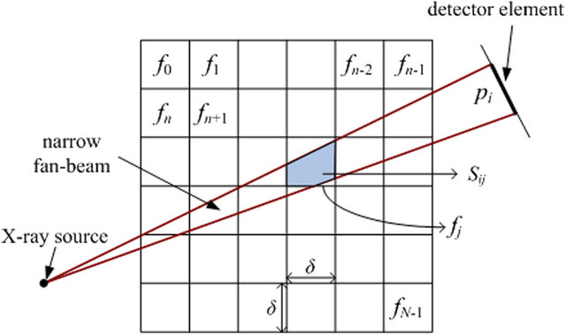

Figure 2:  Area integral model of Algebraic Reconstruction Technique (ART) in the fan-beam geometry.

**3.2. Reconstruct 2D image by ART**



Figure 3: Test image. Many shapes are needed to be reconstructed

First, we need to obtain projections in different angles used to reconstruct the image. We generate projections of this image from 0 $°$ to 179 $°$, 1 $°$ for each projection and we put them together in one image.

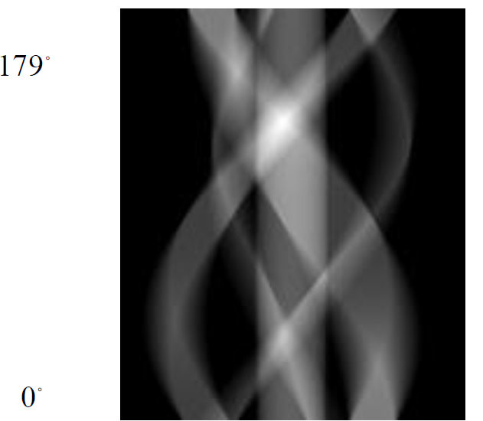

Figure 4: Projections of the image. Every row of this figure is one projection of a certain angle of that angle (1 degree/projection).

According to the principles of ART, we revised a C++ program of ART and successfully reconstruct the original image.



Figure 5: Above image shows results after increasing number of iterations to 100 with relaxation factor 4.

The experiment shows that though reconstructed, the image still has some halo effect which even after post processing was very hard to remove.

**4. SART (Simultaneous Algebraic Reconstruction Technique)**

SART is another popular method in the field of computed tomography. Moreover, SART considers all projection rays in one iteration to reconstruct the image, unlike that ART only uses one ray to reconstruct the image in one iteration. Generally, SART is believed to resist severe noise and can guarantee a better quality of the reconstructed image than ART.

$$f_{j}^{\left(i\right)}=f_{j}^{\left(i-1\right)}+\frac{\sum_{p_{i}∈p_{∅}}{\left[λ\frac{p_{i}-\sum_{k=1}^{N}{f_{k}^{\left(i-1\right)}w_{ik}}}{\sum_{k=1}^{N}{w_{ik}}}\right]}}{\sum_{p_{i}∈p_{∅}}{w_{ij}}}w_{ij}$$

$$j=1,2,….N$$

Therefore, based on this formula, we can know that in

one iteration, SART takes all rays into consideration,

which means that after one iteration, the image will

mostly appear. We take Figure 3 as an example and attempt to reconstruct it. Successfully, we get the result after just one iteration.

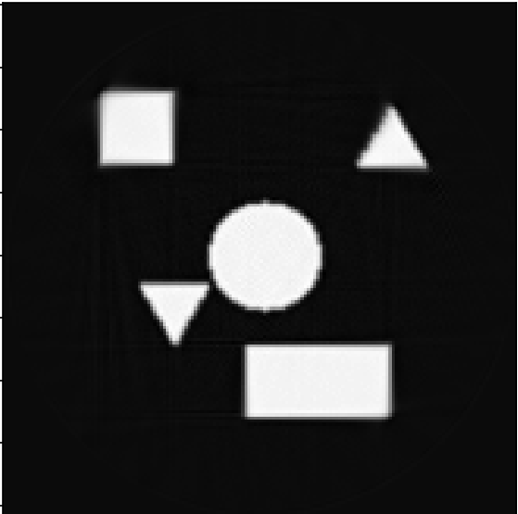

Figure 6: Reconstructed image after using SART. The image shapes are much more prominent and very less halo effect compared to FBP.